

Welcome Pack for Members of

<<INSERT CLUB NAME>>

<<ADD PHOTO HERE>>

Contents
Overview 2
Club Values 2
Welcome Note 3
Key Contacts 3
Training Information 4
Club Locations 4
What to bring to training 4
What to bring to games 4
How to Register <Delete the graphics not required> 5
Game Day Information 16
First Aid Information 17
Injury & Insurance Claims 17
Competition Rules and Laws of the Game 18
Player Expectations & Code of Conduct 18

  - Overview

  - This Welcome Pack has been developed to help provide new and returning players, parents, members and volunteers with clear and consistent information about our rugby club and the wider rugby community.

  - Joining a rugby club can sometimes feel overwhelming, particularly for families and participants who are new to the game. This document is designed to make that experience easier by outlining important information, expectations, key contacts and opportunities available throughout the season.

The purpose of this pack is to:
- Help players and families feel welcomed and connected to the club
- Provide clear information about training, game days and communication processes
- Outline the standards and values expected within the rugby environment
- Support a safe, respectful and inclusive club culture
- Assist new members in understanding how rugby competitions and pathways operate
- Encourage greater involvement from parents, volunteers and supporters

Community rugby is built on strong relationships, teamwork and shared responsibility. Everyone involved in our club – players, coaches, volunteers, officials, parents and supporters – plays an important role in creating a positive environment where participants can develop both on and off the field.

This Welcome Pack should be used as a guide throughout the season and may be updated from time to time as club information changes.

  - Club Values

<Insert club mission or value statement here>

  - Welcome Note

Welcome to the <Club Name> rugby community.

We are excited to have you and your family join our club for the upcoming season. Whether you are new to rugby or returning for another year, we are committed to providing a safe, inclusive and enjoyable environment for all players, volunteers and supporters.

At <Club Name>, we value teamwork, respect, discipline, enjoyment and community spirit both on and off the field.

We encourage all players and families to read through this welcome pack carefully and reach out if you have any questions throughout the season.

We look forward to seeing you at the club.

  - Key Contacts

President – Name – email - phone
Vice President – Name – email – phone
Secretary – Name – email - phone
Treasurer – Name – email - phone
Director of Rugby – Name – email – phone
Women & Girls Coordinator – Name – email - phone
Junior Coordinator – Name – email - phone
Volunteer Coordinator – Name – email - phone
First Aid Contact – Name – email – phone
Member Protection Officer – Name – email – phone
Child & Young Persons Officer – Name – email – phone

Juniors
Coach U7s – Name – email - phone
Manager U7s – Name – email - phone
Coach U8s – Name – email - phone
Manager U8s – Name – email - phone
Coach U10s – Name – email - phone
Manager U10s – Name – email - phone
Coach U12s – Name – email - phone
Manager U12s – Name – email - phone
Coach U14s – Name – email - phone
Manager U14s – Name – email - phone
Coach U16s – Name – email - phone
Manager U16s – Name – email - phone
Coach U18s – Name – email - phone
Manager U18s – Name – email – phone

Seniors
Coach Women – Name – email - phone
Manager Women – Name – email - phone
Coach Third Grade – Name – email - phone
Manager Third Grade – Name – email - phone
Coach Reserve Grade – Name – email - phone
Manager Reserve Grade – Name – email - phone
Coach Premier Grade – Name – email - phone
Manager Premier Grade – Name – email - phone

  - Training Information Based on 2026 participation years. Please change for future years

AGE GRADE | DAY | TIME
U5s (DOB 2021 & 2022)
U7s (DOB 2019 & 2020)
U8s (DOB 2018)
U10s (DOB 2016 & 2017)
U12s (DOB 2014 & 2015)
U14s (DOB 2012 & 2013)
U16s (DOB 2010 & 2011)
U18s (DOB 2008 & 2009)
SENIOR WOMEN (DOB 2009+
SENIOR MEN (DOB 2008+)

Please arrive at least 15 minutes prior to training sessions.

  - Club Locations

Adelaide University Waite Oval, Corner Fullarton Road & Claremont Avenue, Urrbrae
Barossa Barossa Rugby Precinct, 44 Magnolia Road, Tanunda SA 5352
Brighton Brighton Oval, Corner Brighton Road & Highet Avenue, Brighton
Burnside Parkinson Oval, Corner The Parade & West Terrace, Kensington Gardens
Elizabeth Womma Reserve, Corner Womma Road & Peachey Road, Elizabeth
North Torrens Dry Creek Reserve, Corner Churchill Road & Flame Avenue, Dry Creek
Old Collegians Tregenza Oval, Booth Avenue, Linden Park
Onkaparinga Wilfred Taylor Reserve, Sports Park Drive, Morphett Vale
Port Adelaide Riverside Oval, 18 Baynes Place, Port Adelaide
Southern Suburbs AA Bailey Reserve, Cnr Neville & Aldershot Streets, Clarence Gardens
Woodville Gleneagles Reserve, Alisa Avenue, Seaton

What to bring to training

Players should bring:
- Rugby boots
- Mouthguard
- Water bottle
- Training gear suitable for weather conditions
- Any medical items required (e.g. asthma puffer) as well as medical plans

Players should not wear jewelry during training or games

What to bring to games

Players should bring:
- Club issued shorts and socks
- Mouthguard
- Rugby boots
- Water bottle
- Warm clothing for before and after matches
- Any medical items required

Please arrive at least <Insert Time> before scheduled kick-off.

  - How to Register <Delete the graphics not required>

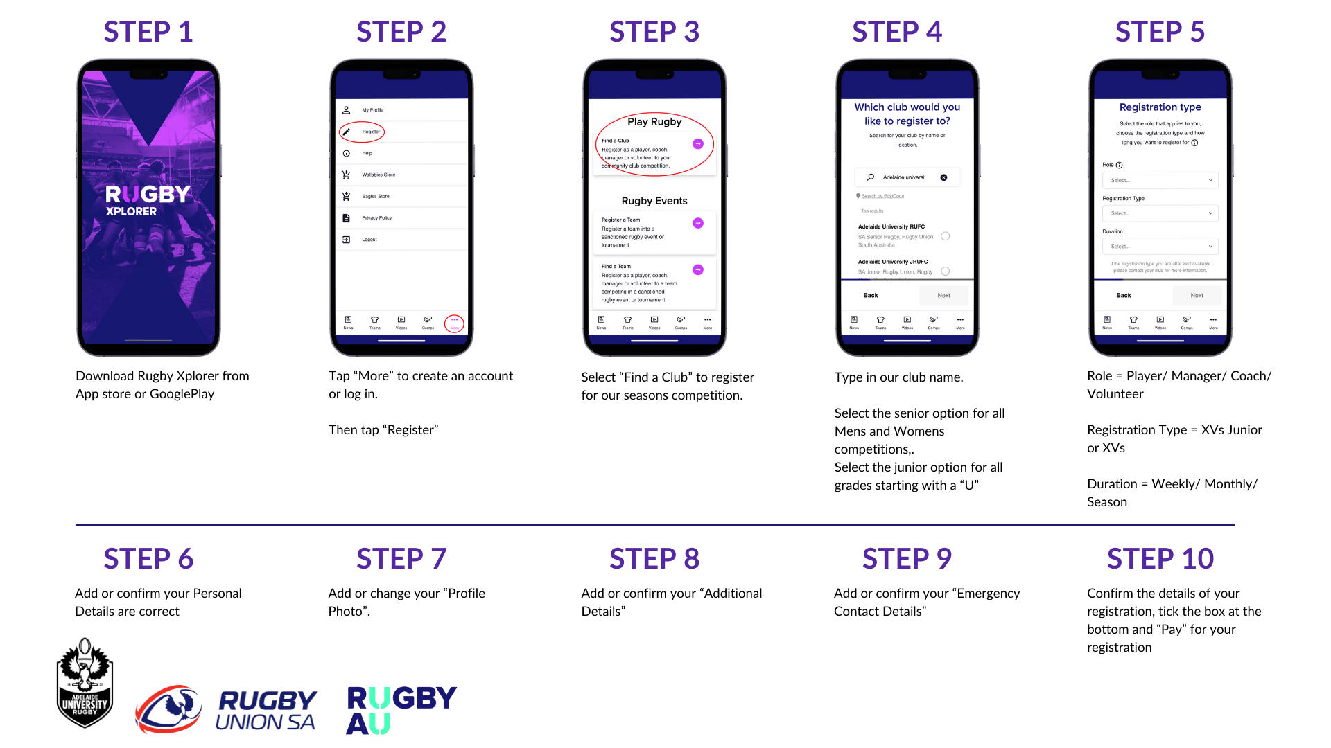
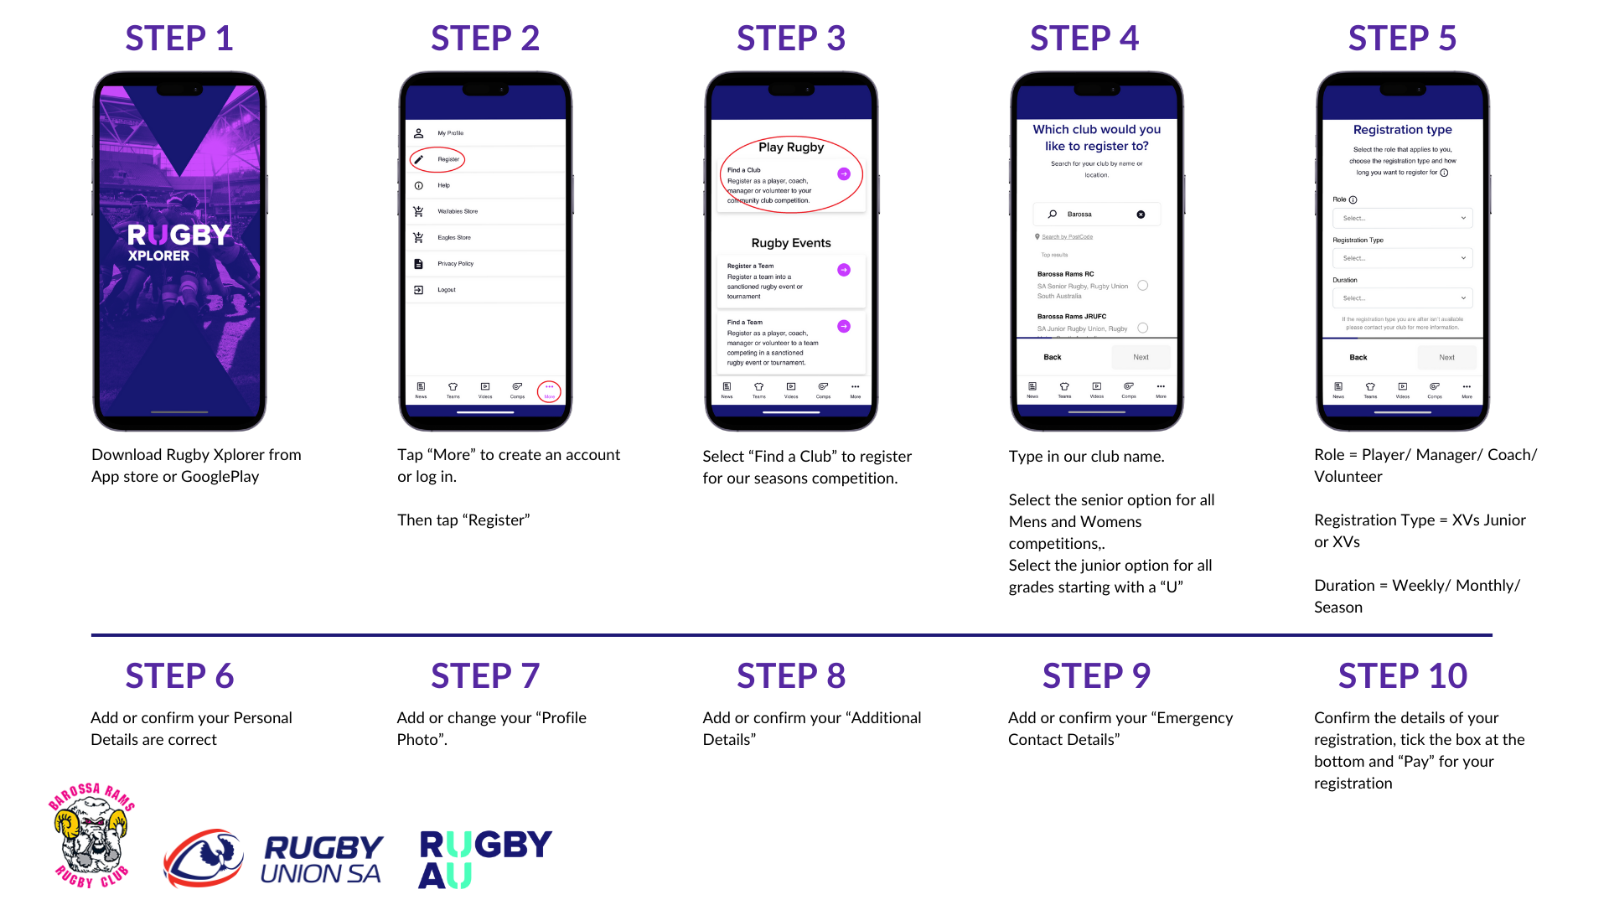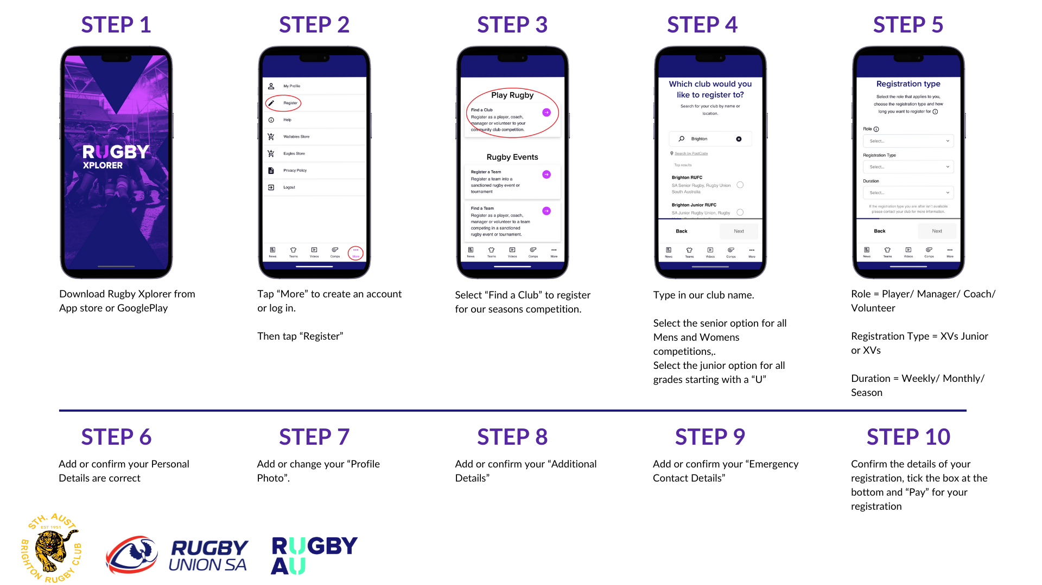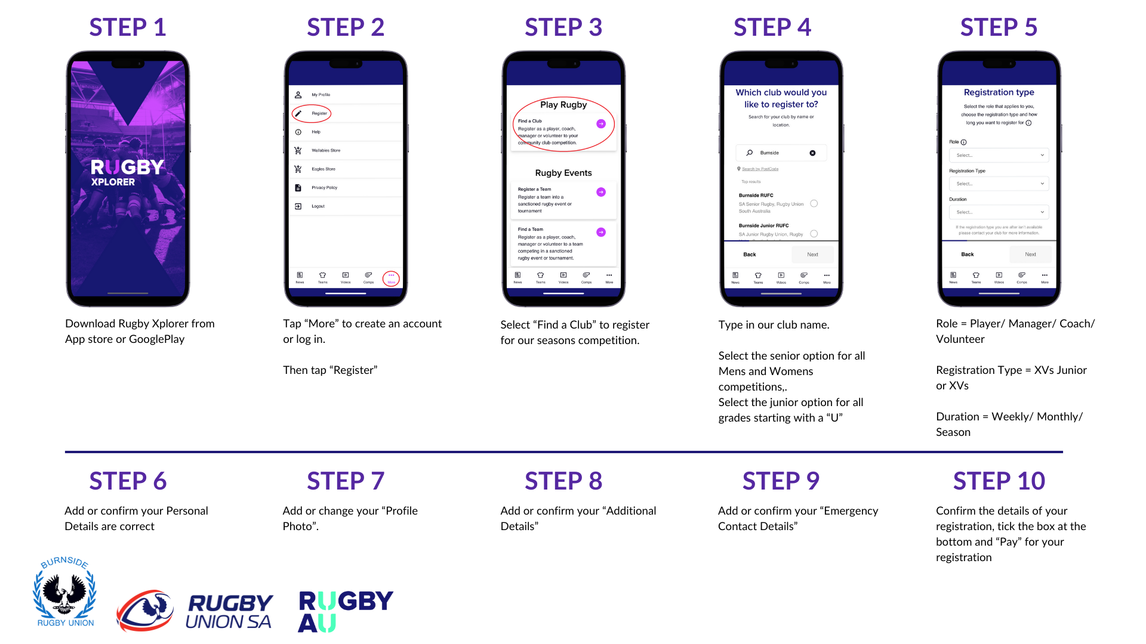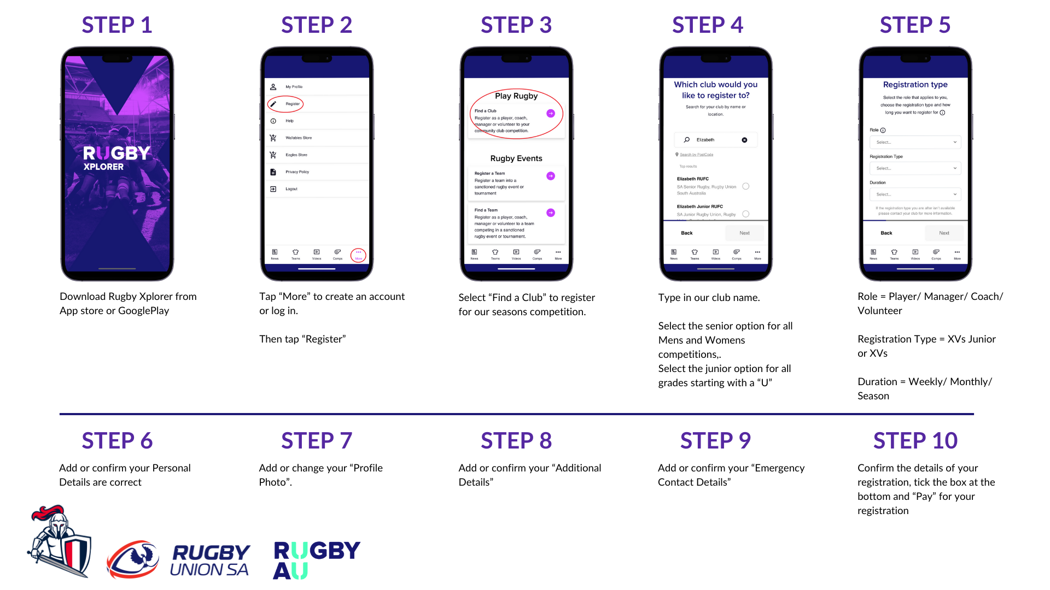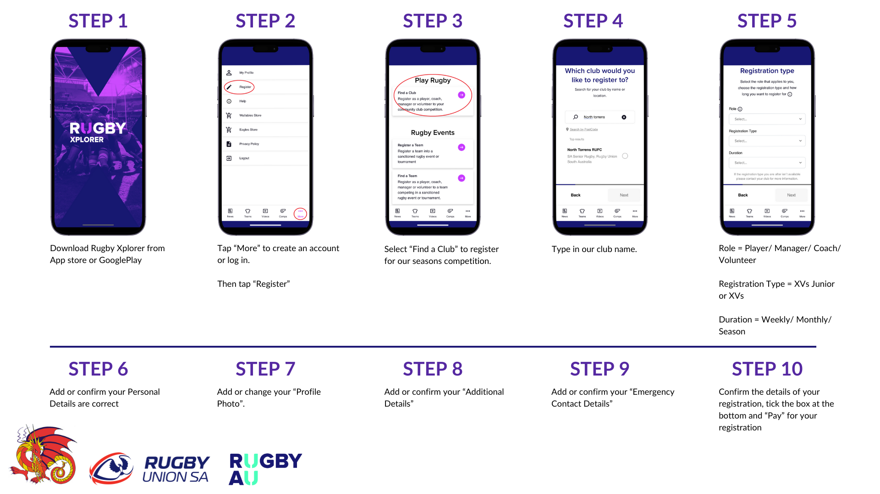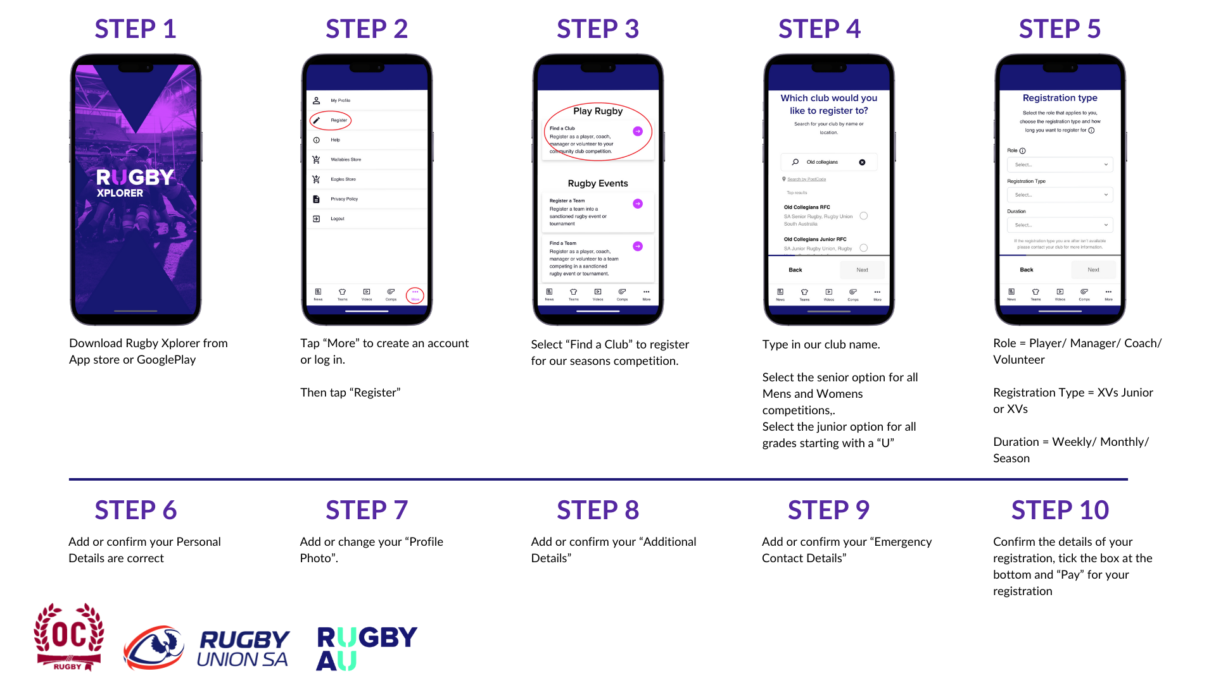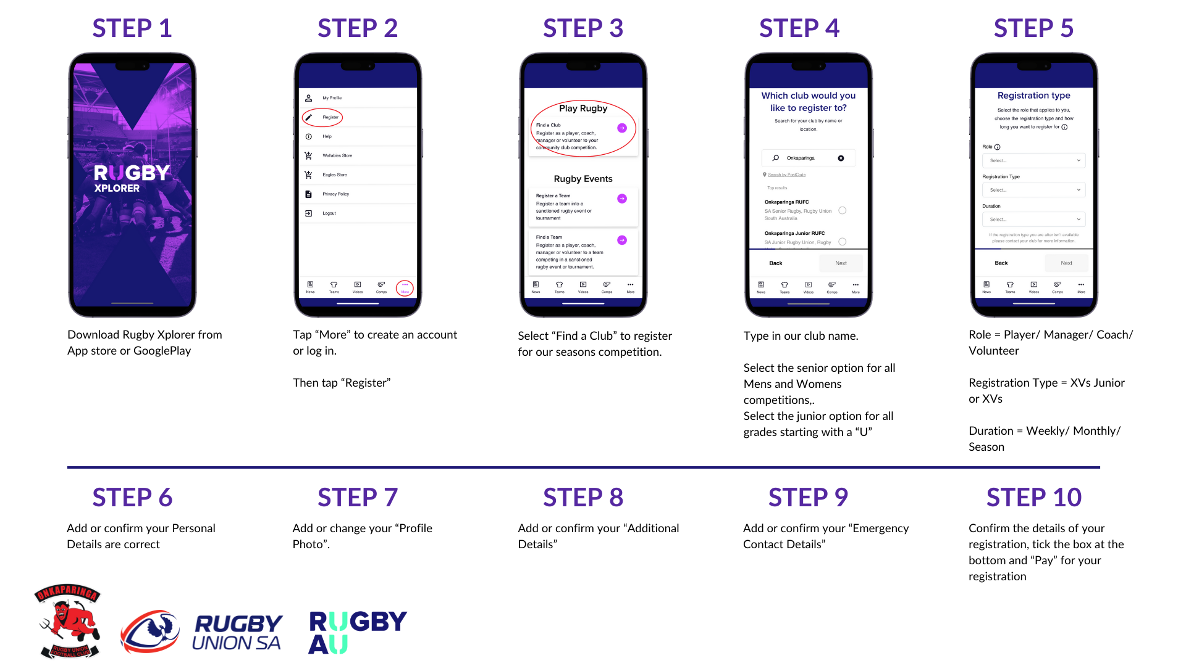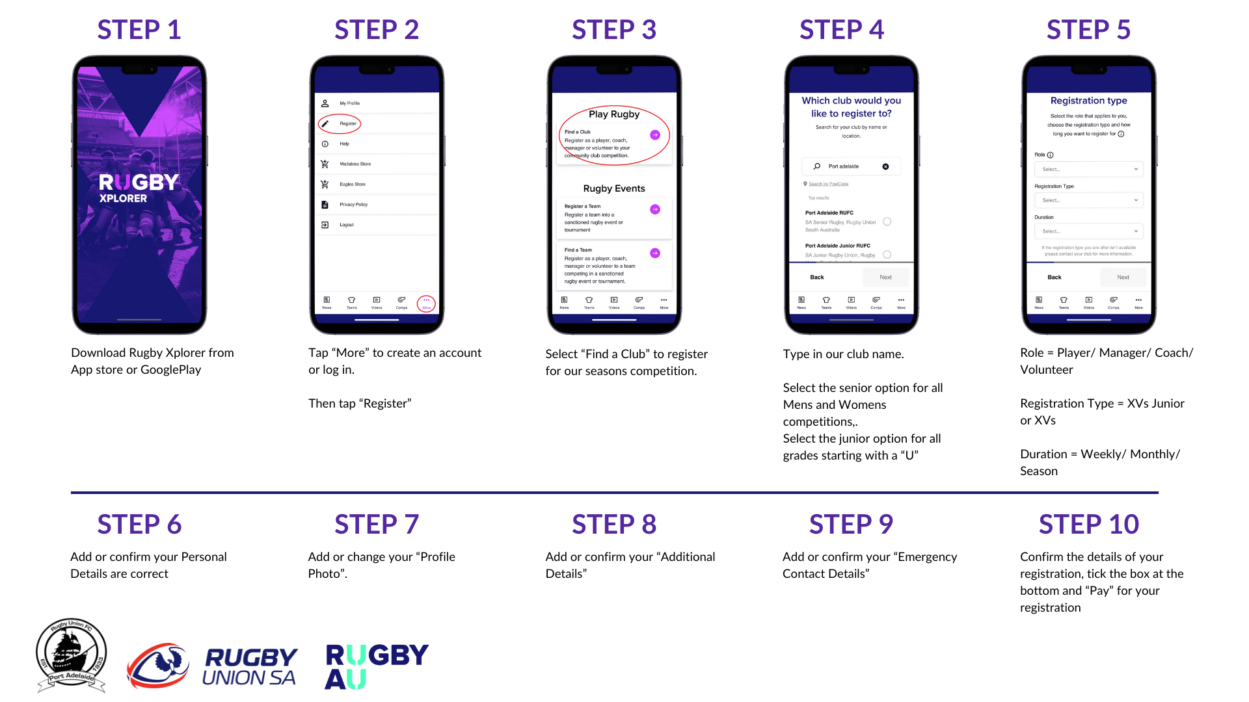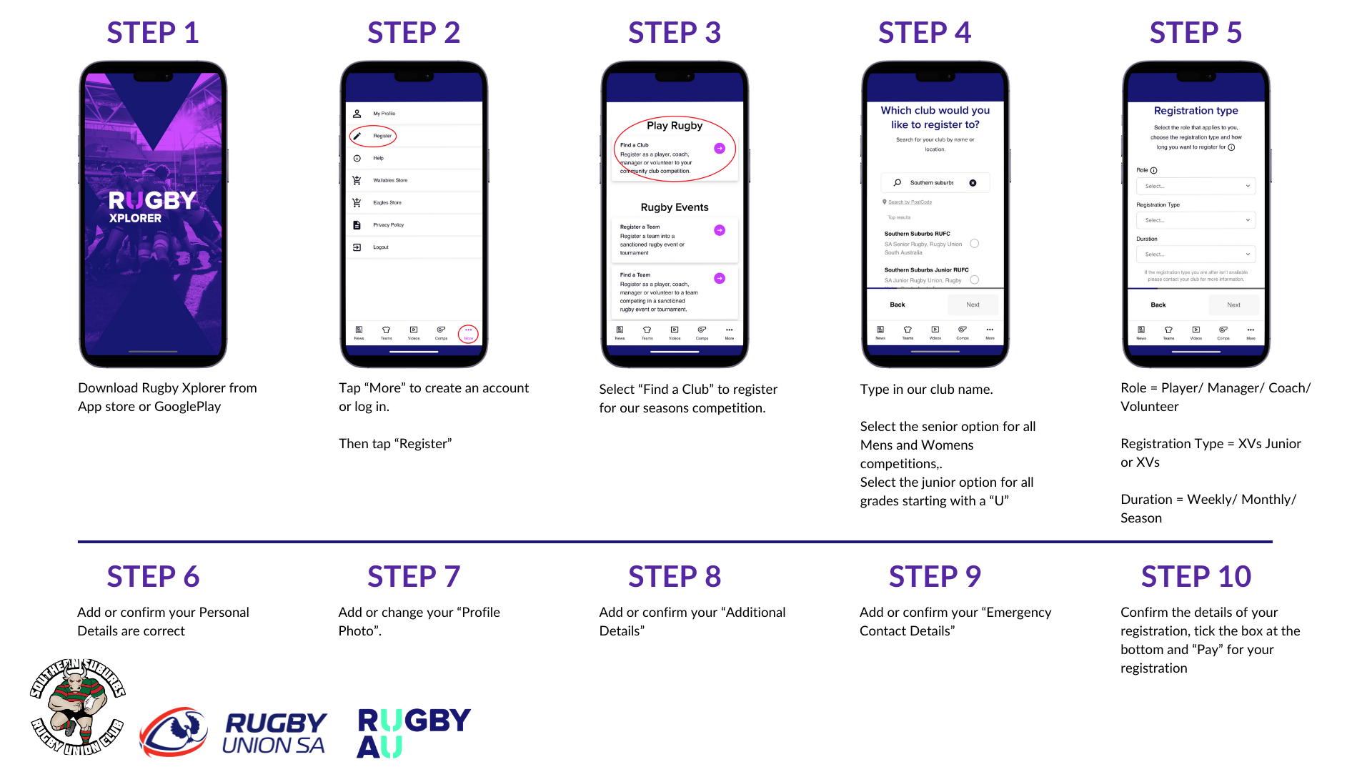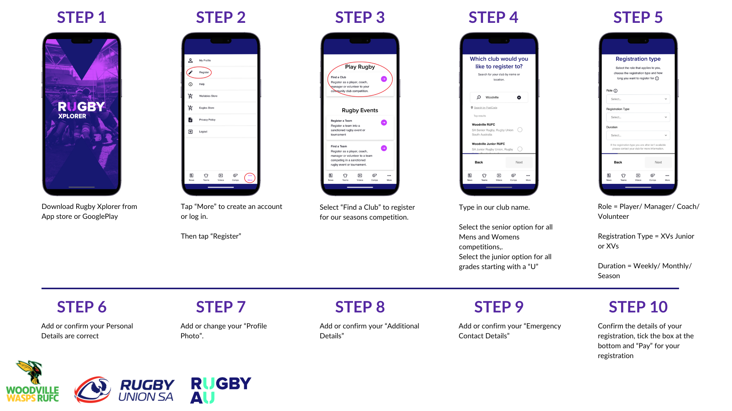


Game Day Information

Rugby Xplorer App

All fixtures, results and team information can be accessed through the Rugby Xplorer App.

Rugby Xplorer is a digital platform that allows rugby players, coaches, officials, and administrators to:

- Register to play, coach, or referee
- Manage teams and competition draws
- Watch matches
- Listen to radio broadcasts
- Access fan content

Rugby Xplorer is available on desktop, laptop, mobile, tablet, and TV. It is used by rugby organisations in Australia, the United States and New Zealand.

To use Rugby Xplorer, players, officials, and non-playing members must self-register and have a personal record in the system. You can download the Rugby Xplorer app for free from the Apple App Store or Google Play Store.

How to follow your Club

- Open the Rugby Xplorer App
- Select “Teams”
- Tap the purple + icon
- Under RAU Community Club, type in your club name then the + button at the end of the row
- Select “Save”

How to find the full year fixture

- Open the Rugby Xplorer App
- Select “Teams”
- Scroll to your club logo
- Tap on the “fixtures” page
- Select your team

Clubs also communicate fixtures and updates through their own social media channels.

How parents & supporters can get involved

Community rugby relies heavily on volunteers and family support. Ways to get involved include:
- Team manager
- Ground marshal
- Canteen volunteer
- Coaching
- Sports trainer / first aid
- Refereeing
- Event support
- Sponsorship assistance
- Committee involvement

No prior rugby experience is necessary for many volunteer roles. If you are interested in helping, please contact: <insert contact details>

First Aid Information

Rugby Xplorer does not have the capabilities to hold information relating to medical/ first aid due to its sensitive nature.

‘Sensitive information’ is governed under the Australian Privacy Act. It has a higher level of privacy protection than other personal information. See https://www.oaic.gov.au/privacy/australian-privacy-principles/australian-privacy-principles-guidelines/chapter-3-app-3-collection-of-solicited-personal-information#collecting-sensitive-information.

We need to know your medical concerns, should an emergency arise. Please provide <insert name> a copy of any current medical plans. All medications should be easily accessible at Training or on Game Days, so please provide to your manager.

Injury & Insurance Claims

Participants are required to register via Rugby Xplorer when participating in any rugby game scenario. Included with the registration, is an insurance component which is broken down into Insurance + Injury Fund Contribution.

Players are entitled to submit a claim for any injury incurred while training and playing rugby union, provided they are:

- A registered participant which does include Training Only
- The match participated in has been sanctioned by Rugby SA.

The manager and/or trainer will lodge an injury report with Rugby Australia, or the players can do so themselves. The person who lodges the report and the injured player will both receive an email from Rugby Australia which includes instructions on how to make a claim against the Rugby Australia insurance. To lodge the initial claim you will need:

- detailed description of the injury and the event that caused it
- the contact details of your usual doctor and attending doctors
- your banking details

https://australia.rugby/about/codes-and-policies/safety-and-welfare/injuries/report

In the event of a suspected spinal injury or fatality the club must call the Serious Injury Case Manager (SICM) on 1800 036 156 in the first instance.

The insurance will cover medical expenses which Medicare doesn't apply to (e.g. private hospital, physio).

- Maximum payable $3000
- Loss of income: 100% of weekly income, Max $300/ week, 28-day excess period
- Domestic help: Max $300/week, Max 52 weeks, 14-day excess period
- Students: 100% of home tutoring, Max $300/week Max 52 weeks, 14-day excess period
- Ambulance (no excess)
- Parents Inconvenience Travel & Accommodation
- Lump sum for permanent injuries / death
- Funeral Expenses

For more information on Insurance cover, please visit: https://australia.rugby/participate/rugby-administration/insurance

Competition Rules and Laws of the Game

All competitions are conducted under the applicable Rugby SA Competition Rules and the Laws of the Game as published by Rugby Australia and World Rugby.

- Rugby SA Competition Rules: https://sa.rugby/administration/rugby-administration
- Rugby Australia Laws of the Game
  - JPP: https://sa.rugby/juniors/jpp
  - U12 – Seniors: https://australia.rugby/participate/referee/laws
- Rugby Australia Concussion Guidance: https://australia.rugby/about/codes-and-policies/safety-and-welfare/concussion-management

Player Expectations & Code of Conduct

All players, members, volunteers and supporters are expected to uphold the values of rugby and contribute positively to the club environment.

Expected standards include:
- Respecting referees, coaches, teammates and opponents
- Demonstrating good sportsmanship
- Attending training and games consistently
- Communicating respectfully
- Following club policies and directions
- Maintaining a safe and inclusive environment

All members are expected to comply with Rugby Australia’s Code of Conduct: https://australia.rugby/about/codes-and-policies/integrity/code-of-conduct

Any behaviour that brings the game or club into disrepute may result in disciplinary action.

As we each have a duty to protect those involved in the game, it is important to report someone who has acted against one or more of our policies, so we can take appropriate action if necessary: https://australia.rugby/about/codes-and-policies/reporting-a-concern

Communication Expectations

Club Communication Channels
The club may communicate through:
- Email
- Team App
- WhatsApp groups
- Facebook
- Instagram
- Website
- Rugby Xplorer

<Insert club-specific communication methods>

Member Expectations
Players and families are expected to:
- Respond to availability requests promptly.
- Notify coaches/ managers if unavailable
- Communicate respectfully
- Raise concerns through appropriate channels
- Stay informed through official club communications

Frequently Asked Questions

What happens if training is cancelled?
Training sessions may occasionally be cancelled due to extreme weather, field closures, safety concerns, public holidays or other unforeseen circumstances.

Where possible, the club will communicate cancellations as early as possible through official communication channels such as email, Team App, WhatsApp, Facebook or SMS.

Families are encouraged to regularly monitor club communications, particularly during periods of extreme heat or wet weather.

What happens if my child cannot attend a game?
If your child is unavailable for a game, please notify the team coach or manager as early as possible.

Early communication helps coaches with team planning, player rotations and ensuring all teams have sufficient player numbers for fixtures.

We understand that family commitments, illness, school activities and injuries may occasionally affect availability. Open and respectful communication is appreciated and helps ensure competitions run smoothly for all participants.

If your child is unable to attend due to injury or suspected concussion, Rugby Australia’s concussion management procedures must be followed before returning to training or matches.

How are teams selected?
Team selections are managed by coaches and club officials with the aim of providing a positive, safe and development-focused environment for all participants.

Selection considerations may include:
- Attendance and commitment
- Player safety and welfare
- Skill development and experience
- Team balance and positional requirements
- Effort, attitude and sportsmanship
- Age and competition eligibility requirements

For junior rugby, player development, enjoyment and participation remain key priorities.

Questions regarding selections should be raised respectfully through the appropriate coach or team manager.

Are mouthguards compulsory?
No, however mouthguards are strongly recommended across all levels of rugby, particularly junior rugby. For junior rugby specifically, mouthguards should be treated as standard protective equipment because they help reduce:
- dental injuries,
- jaw injuries,
- cuts to lips and tongue,
- and some facial trauma risks.

What happens in wet weather?
Rugby is generally played in a variety of weather conditions; however, player safety and field condition considerations may require training sessions or matches to be modified, postponed or cancelled.

Decisions may be made by:
- The club
- Local councils or ground owners
- Competition management
- Match officials

Factors considered may include:
- Lightning or severe storms
- Extreme rain or unsafe playing surfaces
- Ground closures
- Visibility and player safety
- Risk of injury

Where possible, clubs will communicate updates as early as practical through official communication channels. Players should always come prepared for varying weather conditions unless advised otherwise.

Who do I contact with concerns or complaints?
We encourage all members, players and families to communicate concerns respectfully and through the appropriate channels.

In most cases, concerns should first be raised with:
- The Team Coach or Manager
- Member Protection or Child Safeguarding Officer
- The Club Committee or Executive

More serious matters relating to safety, discrimination, bullying, abuse, harassment or misconduct may be managed under Rugby Australia’s Code of Conduct or Member Protection policies.

All members are expected to raise concerns respectfully and allow clubs appropriate time to review and respond to matters.

Can parents stay and watch training?
Yes – parents and guardians are generally welcome and encouraged to stay and observe training sessions, particularly for younger age groups.

Parental involvement and support are an important part of community rugby and help create a positive club environment.

To ensure training sessions remain safe and effective, parents and spectators are asked to:
- Observe from designated areas where possible
- Respect coaches, referees and volunteers
- Avoid entering training areas unless requested
- Allow coaches to coach without sideline interference
- Demonstrate positive and respectful behaviour at all times

Rugby Australia’s Code of Conduct applies to all participants, including parents and spectators, and promotes respectful, safe and inclusive behaviour across all rugby environments.

Sponsors & Community Partners

[Insert sponsor logos and acknowledgements]

