Sponsorship

Sponsorship is the life-blood of all community rugby clubs. These relationships can provide a win-win situation for the club and the business involved. While obtaining businesses who are capable of sponsoring large sums of money are great, it is also important to offer smaller, logo placed sponsorships for local businesses. Not only are these smaller supporters/sponsors of the club likely to return year after year, every dollar counts towards the financial success of the club.

Having a clear plan in regard to sponsorship, will ensure the club can maximise any sponsorship opportunities and reduce any breakdown in the relationship between the club and the sponsor. It may take a bit of work to get a new sponsor on board at a club but takes very little to keep them as long as the club makes them feel included.

Some things to consider when setting up sponsorship opportunities for your club:

- Create, if possible, an exclusive sponsorship opportunity for each industry e.g., real estate, banking, accountant, plumber, electrician etc. This will give each sponsorship exclusive rights in their industry and in their community. It will also enable you to obtain a range of sponsors across many industries.

- Monetise your sponsors with exclusive “naming” opportunities within your club. Rather than just asking for a cash payment, offer a sponsor exclusive naming rights on products within your club e.g. kit, equipment, balls etc. An example of providing naming opportunities to your sponsors is listed below:

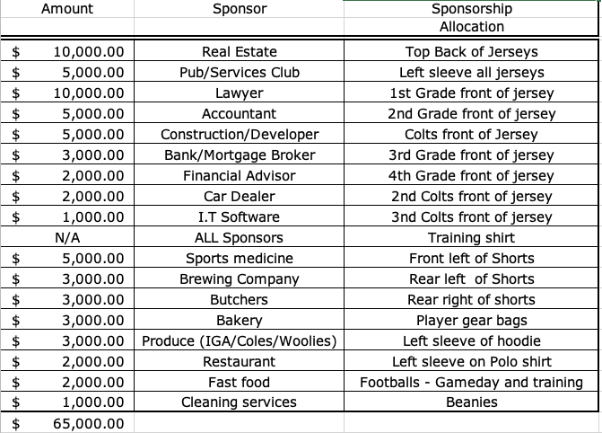

- Sponsorship does not have to be in the form of cash only. Substantial benefits for the club by obtaining non-monetary sponsorship in exchange to logo placement at the club. These may include the following:

BBQ | Discounts obtained from local Bakeries or butchers for the purchase of  bread and meat
Kit | Discounts from local dry cleaners for the washing of playing jerseys
Alcohol | Free or discounted beer/wine from distributers
Cleaning | Discounted or free cleaning from a local cleaning company
Catering | Discounted food from local businesses to provide catering for functions, clubhouse events etc.

- Make sure the sponsorship is cost effective for the club. This means, make sure the monetary value you get from the sponsor is more than the cost to the club for the sponsorship e.g. if the sponsor gets free access to events and home games catering, calculate the cost of their attendance and compare to the money received for the sponsorship.

- Manage the on-going relationship with your sponsor. It is very difficult to get a new sponsor on board, and it is very easy to lose a sponsor if the club does not manage the relationship effectively. Things to consider in maintaining a great relationship with the sponsor:
- Communicate. Make sure you email sponsors a regular newsletter, say every 2 weeks during the season. Keep them up to date on how the club is performing, numbers, special announcements, upcoming and past events.
- Invite them to each home ground and special event the club is holding. Even if they choose not to attend, they do appreciate being invited.
- Speak to the sponsor directly. Sending a regular email is not enough. Make the effort to speak to the sponsor directly either on the phone or at a home game. They do appreciate being singled out and personally updated on the club.
- Have a special day on a home game for sponsors. This is not only a great opportunity for the club to thank the sponsors but it is also a great networking opportunity for all the sponsors of the club. The more business opportunities the sponsor can generate, the more likely the sponsor will continue supporting the club.

