TRFU CHILD PROTECTION POLICY

SAFEGUARDING CHILDREN AND YOUNG PEOPLE

Ensuring the wellbeing and safety of children and young people, including prevention of abuse or maltreatment, is a paramount goal of Taranaki Rugby Football Union. This Safeguarding Children and Young People Policy is part of NZRs ‘Safe clubs Safe Kids’ programme. This policy provides guidance about how to prevent harm from happening to children and young people in Rugby’s care and identify and respond to concerns about the wellbeing of a child or young person, including possible abuse or neglect.

PURPOSE AND SCOPE

This policy reflects Taranaki Rugby Football Union’s (TRFU) vision to provide memorable experiences, inspire Taranaki and enrich lives. We do this whilst living our values of being ambitious, inclusive, connected and leaders. This policy should be read in conjunction with NZRU Child Protection Policy Implementation Guidelines and apply to all TRFU representatives, which includes staff, volunteers, coaches, managers, and players regardless of event, location or environment.
Our Safeguarding children policy supports Taranaki Rugby Football Union employees (permanent, temporary, full-time, part-time, fixed-term and casual), independent contractors, agency employees or work experience personnel) to prevent harm from occurring in the first place in our environments and to respond appropriately to potential child protection concerns, including suspected abuse or neglect.
This policy will at least be known to all staff and will provide specific information for those who will have direct contact with children. It is our organisation’s commitment to protect children from abuse and to recognise the important roles some of our staff have in protecting children.
In addition, Taranaki Rugby Football Union commits to exploring opportunities to work with other providers, including from other sectors, to develop a network of child or young person protection practice in our community.

KEY PRINCIPLES
This policy provides a framework and expectations to protect children, including (but not limited to) staff behaviors in response to actual or suspected child abuse and neglect.

In addition to guiding staff to make referrals of suspected child abuse and neglect to the statutory agencies this policy will also help our staff identify and respond to the needs of the many vulnerable children whose wellbeing is of concern.

We will adopt Prevention Guidelines that act to prevent harm or abuse from occurring while children are in Rugby’s care.

We will act early on warning signs with individuals, teams, or clubs where we believe practices may be putting children at risk.

We also commit to exploring opportunities to work with other providers, including from other sectors, to develop a network of child protection practice in our community.

DEFINITIONS

  - Child or young person – Anyone under 18 years of age.
  - Groups with vulnerabilities -this refers to children or groups who may be exposed to discrimination based on race, sexual orientation, ethnicity, gender, sex, language religion, political opinion, disability, or other status.
  - Harm – Refers to the negative psychological, social, or physical consequences for a child.
  - Duty of care: those who are working with children in rugby must show care, attention, caution, and prudence including following this policy and the procedures contained in it.
  - Safeguarding - the actions we take to ensure all children are safe from harm when involved in our clubs and activities.

  - Designated person for child or young person protection – the manager/supervisor or designated person responsible for providing advice and support to employees where they have a concern about an individual child or young person or who want advice about child or young person protection policy.
  - Disclosure – information given to an employee by a child or young person, parent, or caregiver or a third party in relation to abuse or neglect.
  - Oranga Tamariki - Ministry for Children– the agency responsible for investigating and responding to suspected abuse and neglect and for providing care and protection to children or young people found to be in need.
  - New Zealand Police – the agency responsible for responding to situations where a child is in immediate danger and for working with Oranga Tamariki - Ministry for Children in child or young person protection work and investigating cases of abuse or neglect where an offence may have occurred.

CHILD OR YOUNG PERSON ABUSE
The Oranga Tamariki / Children’s and Young People’s Well-being Act 1989 defines abuse as:

‘…the harming (whether physically, emotionally, sexually) ill-treatment, abuse, neglect or deprivation of any child or young person”.

- Physical abuse is any act that may result in physical harm of a child or young person.
It can be but is not limited to: bruising, cutting, hitting, beating, biting, burning, causing abrasions, strangulation, suffocation, drowning, poisoning, and fabricated or induced illness.

- Emotional abuse is the persistent emotional ill-treatment of a child or young person such as to cause severe and persistent adverse effect on the child or young person’s emotional development. This can include a pattern of rejecting, degrading, ignoring, isolating, corrupting, exploiting, or terrorising. It may also include age or developmentally inappropriate expectations being imposed on children or young people. It also includes the seeing or hearing the ill-treatment of others.

- Sexual abuse involves forcing or enticing a child or young person to take part in sexual activities as well as non-contact acts such as involving children and young people in the looking at or production of sexual images, sexual activities, and sexual behaviours.

- Neglect is the persistent failure to meet a child or young person’s basic physical and/or psychological needs, causing long term serious harm to the child or young person’s health or development. If may also include neglect of a child or young person’s basic or emotional needs.

RESPONSIBILITY OF EMPLOYEES
Taranaki Rugby Football Union is committed to adopting safe practices that act to prevent harm or abuse from occurring while children or young people are in Rugby’s care. Employees will not be expected to assume responsibility beyond the level of their experience and training, however, Taranaki Rugby Football Union does commit to ensuring that employees have access to the information and training they need at the appropriate level for their role.
In view of the above, it is the responsibility of Taranaki Rugby Football Union employees to:

- be vigilant,
- to follow prevention guidelines listed in this policy which set up safe environments for children and limit the chances of harm occurring. (Annexure A)
- have knowledge and awareness of the indicators of neglect, potential or actual abuse,
- and to report any concerns, suspicions, or allegations of suspected abuse immediately and ensure that the concern is taken seriously and reported.

CHILD OR YOUNG PERSON PROTECTION ADISORS (CPA)
Taranaki Rugby Football Union will have an appointed Child or Young Person Protection Advisors (CPA). This function will be held by:
- Emma Edwards
- 021 827 937
- emma@trfu.co.nz

The Taranaki Rugby Football Union CPA will be responsible for carrying out the responsibilities outlined in this policy and per the below:
- To know the decision-making process for concerns of abuse.
- To share NZR resources and NZR contact details when lower end issues have been identified. These are issues that may be below the threshold of reporting to Oranga Tamariki or Police but pose a potential risk to children. (See traffic light tool Annexure C)
- To know the contact details of local Police and Oranga Tamariki – Ministry for Children.
- Record the details of the incident for submitting to Oranga Tamariki- Ministry for Children and to store this information securely.
- Consult with appropriate people in management (CEO, Community Operations Leader) if required.

RESPONDING TO CHILD OR YOUNG PETSON SAFEGUARDING ISSUES

The interests of the child or young person will be the paramount consideration when any action is taken in response to suspected abuse or neglect. Taranaki Rugby Football Union commits to support the statutory agencies (Oranga Tamariki - Ministry for Children) and the New Zealand Police (the

Police) to investigate abuse and will report suspected cases and concerns to these agencies as per the process in this policy.

GUIDELINES FOR RESPONDING TO ISSUES:

- All concerns of potential, suspected, or alleged abuse must be brought to the attention of a CPA at Taranaki Rugby Football Union
- Good decision making is not done in isolation, the CPA will confidentially inform their manager or designated person of the concern, the process, and the outcome.
- CPAs will use the traffic light tool (Annexure C) to determine course of action. All concerns of abuse must be reported to Oranga Tamariki or the police in an emergency. All lower end concerns (for example bullying coaching styles) must be addressed but may be able to be addressed at club level, the CPA can provide advice on this.
- If a child or young person makes a verbal disclosure to an employee, it is important that the employee takes what the individual says seriously.
- Listen carefully to what the individual is saying and are not to interview them or ask too many questions, ask the very basics i.e. Who/When/Where?
- Reassure the child or young person that they have done the right thing but make no promises, e.g. ‘I will keep you safe’.
- Once the basics have been ascertained, no further questions are to be asked. What the individual has said is to be documented, this should include time, date and who was present. This information will be passed onto authorities as soon as possible.
- Advise Oranga Tamariki - Ministry for Children or Police promptly by the CPA, ideally within 48 hours, when a disclosure is made. In case of an emergency, employees are to contact 111 immediately.
- Deciding when and who will inform the parent(s) and/or caregiver will be determined by Ministry of Vulnerable Children (Oranga Tamariki) and Police in consultation with the CPA.

ALLEGATIONS MADE AGAINST EMPLOYEES, VOLUNTEERS, OR REPRESENTATIVES OF OTHER AGENCIES

- Allegations, suspicions, or complaints of abuse against employees, volunteers or representatives of other agencies must be taken seriously and reported to the CPA who will deal with them immediately, sensitively, and expediently within the procedures outlined in this policy.
- It is not the responsibility of the employee to investigate allegations of child or young person abuse.
- If the Police decide to undertake any criminal investigation, then the employee, volunteer or representative of other agencies may be suspended from working with children or young people, without prejudice, as a precautionary measure. It is important that no internal investigation is undertaken, and no evidence gathered that might prejudice the criminal investigation.

CONFIDENTIALITY AND INFORMATION SHARING

Taranaki Rugby Football Union will seek advice from Oranga Tamariki - Ministry for Children and/or the Police before identifying information about an allegation is shared with anyone, other than the service manager or designated person. Employees should be aware that under sections 15 and 16 of the Oranga Tamariki / Children’s and Young People’s Well-being Act 1989 any person who believes that a child or young person has been or is likely to be, harmed physically, emotionally or sexually or ill-treated, abused, neglected or deprived may report the matter to Oranga Tamariki – Ministry for Children or the Police and provided the report is made in good faith, no civil, criminal or disciplinary proceedings may be brought against them. There are additional provisions made under the Privacy Act/Health Information Privacy Code that where there is good reason to do so, such as where there is a serious risk to individual health and safety (see privacy principle 11/Code rule 11), information may be passed onto the correct statutory bodies. NZR will adhere to its own privacy guidelines on keeping documentation confidential and secure.

RELATED LEGISLATION
Oranga Tamariki / Children’s and Young People’s Well-being Act 1989 Privacy Act
Health Information Privacy Code

- APPROVER - Executive Team
- CONTACT PERSON– Community Administrator may be approached on a routine basis in relation to this policy.

- Emma Edwards: emma@trfu.co.nz

ANNEXURE A
Prevention Guidelines

- Follow the ‘Rule of Two’. Adults should avoid situations where they are alone with a child. While acknowledging that occasionally there may be no alternative, for example, where a child falls ill and must be taken home. However, one-to-one contact must never be allowed to occur on a regular basis.
- Any online/text communication should never be one on one, always include the child’s parents/caregivers in messages.
- Follow NZRs police vetting policy which includes identity checking and vetting for all coaches, refs and team managers for teams that include U18s.
- Communicate with children and adults about Child Protection when running events that involve children, to ensure they know who they can talk to about any concerns.
- Follow NZR’s travel guidelines for travel and trips away.

- Adults and leaders at New Zealand Rugby should model healthy, respectful behaviour to both adults and children. Utilise codes of conduct to reinforce this. Examples can be found on Coaching Toolbox website.
- If any form of physical contact is required ask the person’s permission, explain what you are doing and why to both the child and their parents/caregivers.
- Where possible ask parents/caregivers to be responsible for children or young people in changing rooms. Always ensure that whoever supervises does so in pairs.
- Where there are mixed teams away overnight, teams should always be accompanied by an adult male and female coach or helper.
- If it’s necessary to do things of a personal nature for a child, make sure you have another adult accompanying you. Get the consent of the parent/caregiver and if possible, the child. Let them know what you are doing and why.

- If you need to transport a child alone have them sitting in the back seat of the car and take them directly home rather than detour to other places on the way.
- Don’t allow physically rough or sexually provocative games, or inappropriate talking or touching.
- Ensure that any claims of abuse by a child are taken seriously and that the guide to report suspected or actual abuse included as an appendix is followed.
- Ensure that the nature and intensity of training and competition does not exceed the capacity of a child’s immature growing body and ability.
- Ensure that use of photographic images and video are aligned to relevant privacy policies.
- That all people responsible for children and young people at any given time should always remain in an alcohol-free state, so that they can react appropriately to any situation that might arise.
- Those over 18 should always maintain appropriate social, sexual, and physical boundaries with those under 18, this includes not forming or pursuing sexual relationships with under 18s.

ANNEXURE B

Steps for reporting suspected or actual child or young person abuse.
ABUSE IS EITHER SUSPECTED OR DISCLOSED
- Ensure the child or young person is safe from immediate harm.


LISTEN
- Listen carefully to what the child or young person is saying DO NOT interview the child or young person or ask too many questions, ask the very basics i.e. Who/Where/When? Reassure the child or young person they have done the right thing.
- Once you have ascertained the basics DO NOT question them further. Document what the child or young person said word for word, include time, date and who was present, so you can pass this information to authorities as soon as possible. Report your concern to the NZR CPA
POLICE
- The Police have a dedicated team of investigators who focus on child or young person.
- Deciding when and who will inform the parent(s) and/or caregiver will be determined by Oranga Tamariki and Police in consultation with the NZR CPA. Report early so there is time to consider what’s best for the child.
- Police and Oranga Tamariki will arrange interviews of the children or young people.
- DO NOT conduct an investigation of your own before making a report of concern.
HOW TO REPORT YOUR CONCERN
- If you ever think a person is in immediate danger, call the Police (111).
- Advise Oranga Tamariki – Ministry for Children on 0508 FAMILY (0508 326 459) or Police promptly when a disclosure is made.
ANNEXURE C

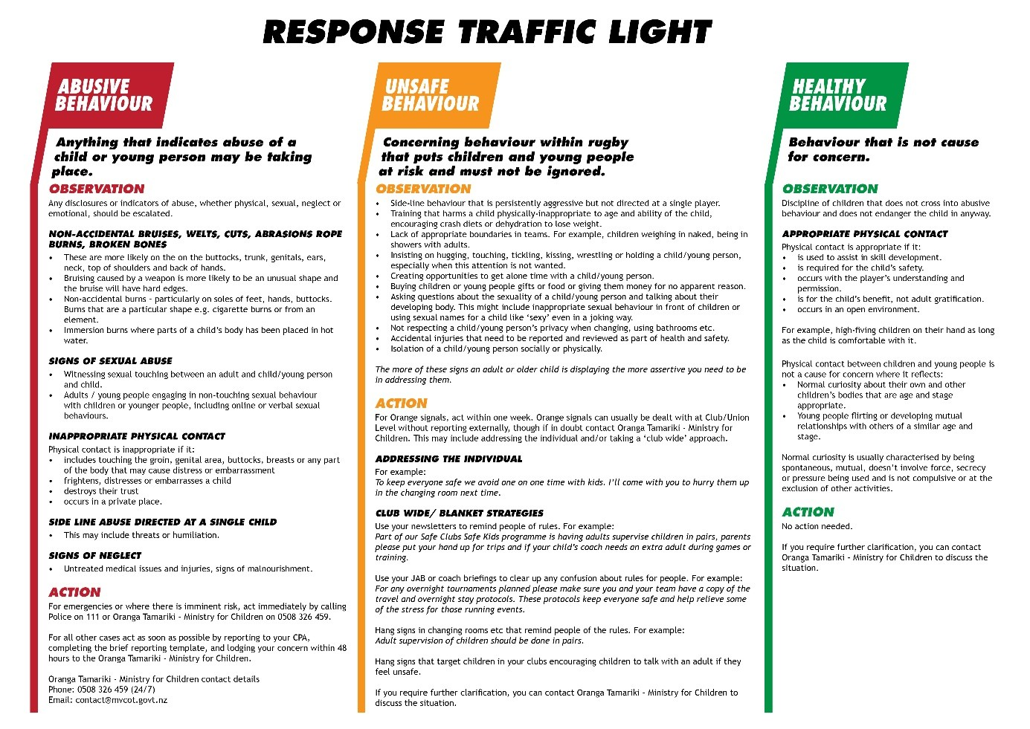
Traffic Light for Responding

