

Grass Roots Rugby

Team Manager Guide

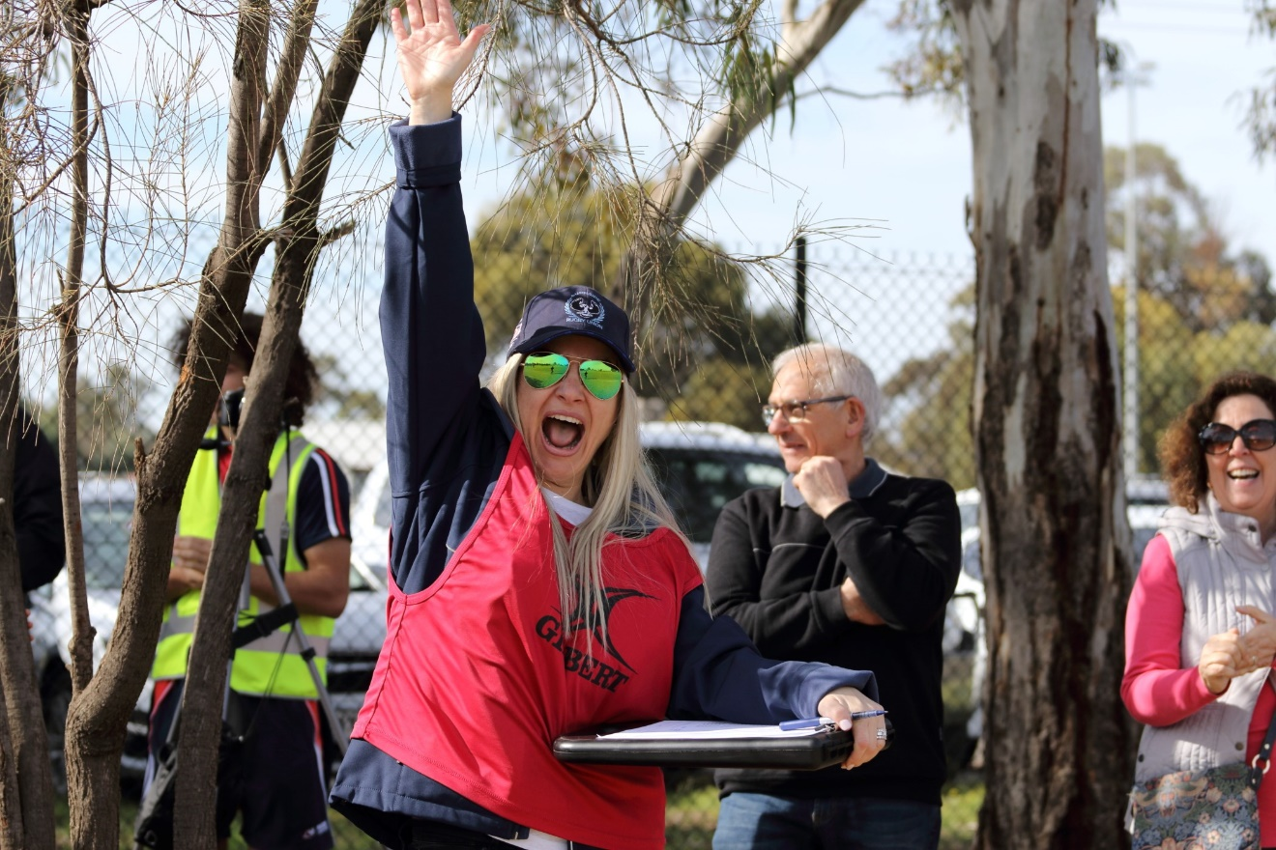

Contents
Overview 2
Working with Children Checks 3
Accreditations 3
SA Government Sport Vouchers 3
Team Communication 4
Junior Age Grade Competitions 5
Report a Concern 6
First Aid Information 7
Injury & Insurance Claims 8
Concussion/ Blue Card Management 9
Rugby SA Policies and Procedures 10
Role of Ground Marshal 10
Rugby Australia’s Apps 11
Rugby Australia’s Disciplinary Rules 12

Overview

A Manager’s job is to maintain the general running of a team to free the coach to concentrate on the coaching and training aspects of the team. A Manager should also be a liaison person between team/ coach/ parents/ information officers and the office administration. Team Mangers work closely with the Coach to bring about a high level of team spirit & camaraderie within the team and with all other members of the Club.

A team manager's role in sports is to ensure the team runs smoothly and the athletes are well cared for.

They are responsible for a variety of tasks, including:

                - Liaison: Acting as a liaison between the team, coaches, parents, and club administration
                - Organization: Coordinating logistics for training, games, and other activities
                - Safety: Ensuring the team has safe equipment, first aid kit, and drink bottles
                - Administration: Managing paperwork, scheduling, and communications
                - Welfare: Ensuring the welfare and safety of the team
                - Team spirit: Working with the coach to build team spirit and camaraderie
                - Game day: Completing team sheets, try scorers, substitutions, and best and fairest votes
                - Team managers need to be organized, flexible, and alert, and be able to adapt to changing situations. They should also be able to multitask efficiently.

Key Contacts

Competition Manager – Fraser Brydon – fraser.brydon@rugby.com.au -
Competition Administrator – Rose Jackson – rose.jackson@sa.rugby – 0428 367 109
Running Rugby Customer Service – runningrugby@rugby.com.au – 02 8005 5600
Integrity – integrity@sa.rugby

Working with Children Checks

To begin with, all individuals who will be in the role of a manager in a team with minors (including womens teams), must have a valid Working with Children Check (WWCC) in place before they begin their role. It's an offence to do child-related work without a WWCC.

To apply for a check, you will need items to verify your identity such as a birth certificate, passport, citizenship certificate, drivers’ licence or proof of age card as well as address details for the last five years.

Volunteer WWCC do not have a cost associated with them in South Australia. WWCC are not unique to each organisation you work with – and the same details can be shared across Organisations. It is important you keep and share the email sent from the DHS Screening Unit with each Organisation, which shows your reference number in the format SRN XXXX-XXXX.

To apply for a check, click here: https://www.dcsiscreening.sa.gov.au/SCRequestApplicationIndividual

Accreditations

From 2025, Managers will be required to have Team Manager Program accreditation. This course is available in Rugby Australia’s Learning Centre and shows individuals how to use Rugby Xplorer and Match Day app effectively. Accreditation does not expire; however, managers can complete the accreditation yearly if they wish.

SA Government Sport Vouchers

Starting January 1, 2025, the South Australian Sports Vouchers program will offer two $100 vouchers per year for children in Reception to Year 9.

Eligibility: Children in Reception to Year 9 living in South Australia
Activities: Vouchers can be used for a number of sports including Rugby Union.
Usage: Parents can use the vouchers for two separate activities, or claim a $200 deduction on fees for one activity.

It is important to note, that Rugby Union registrations are made up of
- National Insurance
- State Component
- Association Component
- Club Component

Families need to download their voucher, complete all details within, and provide to their club of choice. https://www.sportsvouchers.sa.gov.au/how-to-use-voucher/

Team Communication

There are now several ways that Manager can communicate within the Team environment. Managers should check in with their Junior Co-Ordinator or Club Committee to determine what communication tool the club uses These include:

                - Email
                - Text message
                - WhatsApp (currently most popular with the younger generation)
                - Facebook Groups/ Messenger
                - Heja App - https://heja.io/
                - Stack App - https://www.teamapp.com/?_detail=v1

Emails and text messages sent to a Child should always be copied to their parents or guardians. Where a parent is not included in a communication, then a Relevant Person must be able to provide reasons for this and must:

a) restrict such communication to issues directly associated with delivering Activities, such as advising that a scheduled event is cancelled;

b) limit the personal or social content in such communications to what is required to convey the service-related message in a polite, friendly manner. A Relevant Person must not communicate anything that a reasonable observer could view as being of a sexual or inappropriate nature;

c) not use such communication to promote unauthorised ‘social’ activity or to arrange unauthorised contact;

d) not request a child keeps a communication secret from their parents; and

e) not communicate with children using internet chat rooms or similar forums such as social networking sites, game sites or instant messaging from personal profiles or accounts.

Relevant Persons are required to ensure the appropriate monitoring of Children when they use a Relevant Organisation’s electronic communication equipment so that they do not inadvertently place themselves at risk of abuse or exploitation via social networking sites, gaming sites or through web searches, or inappropriate email communication.

Junior Age Grade Competitions

Rugby Union SA hosts competitions for both male and female players, starting at 4 years old through to Masters Rugby.

The starting policy position is that a player may play in the age group he/she is turning in the relevant calendar year and in the age group one year above. For example, a player turning 15 in the relevant calendar year (1 January – 31 December) is eligible to play in the Under 15 age group and the Under 16 age group.

Players may be eligible for a dispensation based on Rugby Australia’s Dispensation Guidelines which states “A player’s physical development in conjunction with their ability and/or experience may be such that he or she may be allowed to participate in an age grade competition that is one year above or one year below their eligible age grades.”

For example, a player turning 15 in the relevant calendar year who is already eligible to play in the Under 15 age group and the Under 16 age group, may receive dispensation to be able to participate in the Under 14 age group or Under 17 age group. A player turning 19 in the relevant calendar year may receive dispensation to play in an Under 18 competition.

Types of Dispensations available:

- Age Grade including Size for Age
- Mixed Gender
- U8 (for players who are 7 years old and want to play contact rugby)
- Senior Rugby
- Schedule B (for players who want to play in the Front Row in a Senior Grade, or an Age Grade 2 years above their Actual Age Grade.)
- Disability
- Gender Identity

Dispensation requests are processed by Rugby SA and assigned to coaches based on the following guidelines:

- Age Grade Down, assessment completed by Rugby SA or a Coach assigned by Rugby SA
- Size for Age, assessment by Club Assessing Coaches

The following dispensations are required for players participate in a game:

- Girls who are 13, 14 and 15 must have a mixed gender dispensation to participate in U14 Competition
- Girls who are 16 are required to play in the U16 Youth Girls Program. Dispensation requests can be considered once the Womens Challenge Cup has been played.
- Girls who are 17 need an Assessing Coach to sign them off to play Womens
- Boys and Girls who turn 18 need parental consent for senior dispensations.

2026 Age Grade Guidelines:

Year Born | Age Grade | South Australia Competition | Possible dispensation UP to:
Born in 2022 | U4 | U4-U5 GiR
Born in 2021 | U5 | U4-U5 GiR
Born in 2020 | U6 | U6-U7 GiR
Born in 2019 | U7 | U6-U7 GiR | U8
Born in 2018 | U8 | U8 | U10
Born in 2017 | U9 | U10
Born in 2016 | U10 | U10 | U12
Born in 2015 | U11 | U12
Born in 2014 | U12 | U12 | U14
Born in 2013 | U13 | U14
Born in 2012 | U14 | U14 | U16
Born in 2011 | U15 | U16
Born in 2010 | U16 | U16 | U18
Born in 2009 | U17 | U18
Born in 2008 | U18 | U18 | SENIORS

Report a Concern

Rugby Australia’s policies and procedures aim to ensure the game is run effectively, fairly and safely and that all participants behave in a positive and appropriate manner.

As we each have a duty to protect those involved in the game, it is important to report someone who has acted against one or more of our policies, so we can take appropriate action if necessary.

Rugby Australia have an online platform where complaints can be raised directly by individuals. Should someone raise a concern with yourself, please direct them the clubs Member Protection Officer as well as to the website where they can report themselves under one of the following categories:

- Child Safeguarding
- Code of Conduct
- Match Official Abuse
- Sexual Harassment
- Other Incident
- Doping, betting or Corruption Incident

Reports relating to child protection concerns will be made through Rugby AU’s independent reporting platform – Speak Up. This platform is independently managed by our integrity partners, Core Integrity, who are experienced in dealing with complex and sensitive disclosures and allegations. You may also remain anonymous through this platform if you wish.

All other concerns will be referred to your State Union representative and manager of the competition that you select from the drop-down menu.

https://australia.rugby/about/codes-and-policies/reporting-a-concern

First Aid Information

Rugby Xplorer does not have the capabilities to hold information relating to medical/ first aid due to its sensitive nature. Clubs can ask their membership base “custom questions” which participants answer at the time of registration.

‘Sensitive information’ is governed under the Australian Privacy Act. It has a higher level of privacy protection than other personal information. See https://www.oaic.gov.au/privacy/australian-privacy-principles/australian-privacy-principles-guidelines/chapter-3-app-3-collection-of-solicited-personal-information#collecting-sensitive-information.

Clubs are encouraged to create their own Medical/ First Aid questionnaires which ask relevant questions which can used.

Questions should be based on a “needs to know” basis, such as:

- Player Name, age, email address, phone number
- Emergency Contact name & phone number
- Any known conditions
  - ADHD
  - Allergies
  - Anaphylaxis
  - Asthma
  - Blackouts
  - Diabetes
  - Epilepsy
  - Fainting
  - Hepatitis A or B
  - Heart Conditions
  - HIV
- If yes to any of the above, please provide a copy of your emergency treatment plan to Club Secretary
- If you are currently on a medical plan that does not relate to the above, please provide a copy to Club Secretary

Information should be collected online through Microsoft Forms or Google Docs.

Medical Information and Plans should be shared with Team Manager, and stored in a safe place.

Injury & Insurance Claims

Participants are required to register via Rugby Xplorer when participating in any rugby game scenario. Included with the registration, is an insurance component which is broken down into Insurance + Injury Fund Contribution.

Players are entitled to submit a claim for any injury incurred while training and playing rugby union, provided they are:

- A registered participant which does include Training Only
- The match participated in has been sanctioned by Rugby SA.

The manager and/or trainer will lodge an injury report with Rugby Australia, or the players can do so themselves. The person who lodges the report and the injured player will both receive an email from Rugby Australia which includes instructions on how to make a claim against the Rugby Australia insurance. To lodge the initial claim you will need:

- detailed description of the injury and the event that caused it
- the contact details of your usual doctor and attending doctors
- your banking details

https://australia.rugby/about/codes-and-policies/safety-and-welfare/injuries/report

In the event of a suspected spinal injury or fatality the club must call the Serious Injury Case Manager (SICM) on 1800 036 156 in the first instance.

The insurance will cover medical expenses which Medicare doesn't apply to (e.g. private hospital, physio).

- Maximum payable $3000
- Loss of income: 100% of weekly income, Max $300/ week, 28-day excess period
- Domestic help: Max $300/week, Max 52 weeks, 14-day excess period
- Students: 100% of home tutoring, Max $300/week Max 52 weeks, 14-day excess period
- Ambulance (no excess)
- Parents Inconvenience Travel & Accommodation
- Lump sum for permanent injuries / death
- Funeral Expenses

For more information on Insurance cover, please visit: https://australia.rugby/participate/rugby-administration/insurance

Concussion/ Blue Card Management

A concussion is a brain injury and must be taken seriously. All players with potential head injuries or concussion must be removed from the field of play immediately.

A player suspected of having suffered a concussion will be shown a blue card by the match referee and will take no further part in the match. The manager for the team is required to use the Rugby Match Day app, and record the Blue Card against the player’s name. Details on how to use Rugby Xplorer will be listed on page 11.

In matches of U13 and older, when a player leaves the field due to signs and symptoms of concussion or suspected concussion, the referee will show the player a Blue Card. This card is a visual cue for team support staff, it must be recorded by team officials, and triggers an off-field medical process to begin.

At the conclusion of all games, Managers should be checking with the Match Officials that all cards have been recorded in Match Day correctly,

If a player has received a concussion at training, the manager (or coach) should notify the Club Secretary who will record a Competition Case against the player’s record.

Process to follow for Concussion Management
Stage 1. On The Day of the Injury
RECOGNISE - REMOVE - RECORD - REFER

If a player has signs or symptoms of a potential head injury or concussion no person (e.g. physio, coach, trainer, or doctor) can over-ride the requirement of a player to remain off the field.

The following documents must be printed off and provided to a player, or parent/guardian, on the day of the injury:

- Rugby Australia Head Injury Fact Sheet
- Rugby Australia Referral & Return Form

Stage 2. On The Days Following the Injury
REST - RECOVER - RECORD - RETURN

For any player is diagnosed as having concussion the stepwise graduated return to play (GRTP) process must be followed. The referral & return form must be completed.

If this isn’t completed the player will be excluded indefinitely from full contact training and match play.

Once a player has been cleared of their concussion by having their doctor sign off on the paperwork, all 3 sections must be scanned and sent to the Competition Administrator for Rugby SA.

Rugby SA Policies and Procedures

Rugby SA have developed a number of policies and procedures to help with the governance and administration of the local competition.

Managers from Junior Age Grade through to Senior Rugby, should be familiar with each policy should any questions arise.

Policies and procedures are reviewed each year and are housed on the Rugby SA website: https://sa.rugby/competitions/seniors/rugby-administration

- Competition Rules – overarching standards and procedures that ensure the competition in South Australia is conducted safely, fairly and consistently across all participants and clubs.
- Game On Rules – flexible, participant-focused regulations designed to ensure matches proceed when teams have fewer than 15 players.

Role of Ground Marshal

Each team competing in a Rugby Union South Australia (RUSA) sanctioned match or event is required to have a Ground Marshal as a member of their Team Management.

A Ground Marshal must be minimum 18 years of age and be wearing a high-visibility outer garment so they are easily identifiable in their role – ideally a purple vest marked with “Marshal”.

A Ground Marshal must be an individual who is only responsible for that role (i.e. must not occupy 2 roles for that match). By exception (e.g. where a team is playing away from the rest of the Club), the Team Manager could also be the Ground Marshal for that match. All other roles, cannot share the Ground Marshal role (e.g. you cannot be a Ground Marshal and also be a Coach, Player, Water Runner, Trainer, Photographer etc.)

Ground Marshals must:

- Monitor and manage spectator behaviour for the duration of the match
- Support Match Officials with Red/ Yellow Card management
- Enter the field of play if the Referee has stopped the game and requires support (e.g. for serious injury or dealing with sideline behaviour)
- Monitor the Technical Zones

Rugby Australia’s Apps



Rugby Xplorer is a digital platform that allows rugby players, coaches, officials, administrators, and fans to:

- Register to play, coach, or referee
- Manage teams and competition draws
- Watch matches
- Listen to radio broadcasts
- Access fan content

Rugby Xplorer is available on desktop, laptop, mobile, tablet, and TV. It is used by rugby organizations in Australia, the United States and New Zealand.

To use Rugby Xplorer, players, officials, and non-playing members must self-register and have a personal record in the system. You can download the Rugby Xplorer app for free from the Apple App Store or Google Play Store.


Rugby Match Day app is a tool for team managers to manage rugby matches, including pre, during, and post-match tasks. It's available on the Apple App Store and Google Play Store.

The app allows users to:

- Select teams,
- Live score,
- Enter results,
- Record statistics,
- and Document incidents and injuries.

The app supports both regular and dual scoring modes. In regular scoring, only one user scores the match, while dual scoring allows a primary and secondary user to score the same match simultaneously.

To access the Rugby Match Day app, users must be granted "team admin" permissions and have a primary account with an email address on their profile. Multiple users can access the same team, but it's recommended that only one user scores at a time.

Help videos are available within the app's "More" tab:

- Entering a Squad List
- Selecting Team List making sure player jersey numbers match the players.
- Live Scoring including substitutes, entering cards & injuries,

Rugby Australia’s Disciplinary Rules

Appearing before a Judicial Committee at a hearing can be stressful and sometimes even overwhelming and confusing.

Rugby Australia has developed the Rugby Australia Disciplinary Rules (“the Rules”) to maintain and promote fair play, protect the safety and welfare of Players, ensure that acts of Foul Play are dealt with expeditiously and appropriately by independent means within the Game, and that the image and reputation of the Game is not adversely affected. The Rules also ensure that there is uniformity in the way disciplinary procedures are administered in the Game across Australia.

After receiving a Red Card or Citation, the Player will be contacted by Rugby SA Competitions Administrator.

The Competitions Administrator will advise you (and anyone else necessary such as your coach or club president):
- the date and time of your judicial hearing
- whether the hearing will be held in person or online.
- Judicial Process FAQs

Hearings are typically held on a Wednesday evening following a weekend of matches. You will be given as much notice as possible, but it could be as short as 24 hours.

Players will be given:
- the Send-Off Report, and
- any relevant evidence such as witness statements, medical reports or video footage.

Before a hearing, it is important all parties read the Disciplinary Rules and Sanction Table in Annexure 1 and 2. This can be found via Rugby SA website: https://sa.rugby/administration/judiciary

Bring any evidence needed to rely on when defending yourself. This could be:
- video footage
- photographs
- witness statements, or
- anything else you feel may help your case.

Child or Children means a child or young person, or two or more children or young persons, who is or are under the age of 18 years.
Relevant Person means any of the following persons: a) Individual Member; b) Participant; c) Employee; d) Contractor; e) Volunteer which means any person engaged by a Relevant Organisation or in a rugby Activity in any capacity who is not otherwise an Employee or Contractor, including directors and office holders, coaches, officials, administrators and Team and support personnel; and f) Any other individual who has agreed to be bound by Rugby Australia’s Child Safeguarding Policy.

